Based on the datasets printed in Module 4 Challenge, one can see that students that attend a Charter School have a higher likelihood to pass in comparison to students that attend a District School. This can be determined when reviewing figure 1 and figure 2. It is also important to discuss how the data shows that students overall passing rate is more closely related to the size of the school as opposed to the common misconception that it is the budget, i.e., spending per student, that makes the true difference. Figure 3 distinguishes that schools with 2,000 or less students have an overall passing rate greater than 89% whereas schools with 2,000 or more students have an overall passing rate of less than 60%. Furthermore, Figure 4 demonstrates that schools that spend$585- $630 per student have an overall passing rate over 80%, even more so when less than $585 have an overall passing rate over 90%. Whereas, schools spending more than $630-$645 per student have an overall passing rate of roughly 63%, even more so when schools spend more than $645 the overall passing rate drops to roughly 53%. In conclusion, the variables ‘school size’ and ‘percent overall passing’ are inversely correlated and the variables ‘per student budget’ and ‘percent overall passing’’ are inversely correlated.

Figure 1:

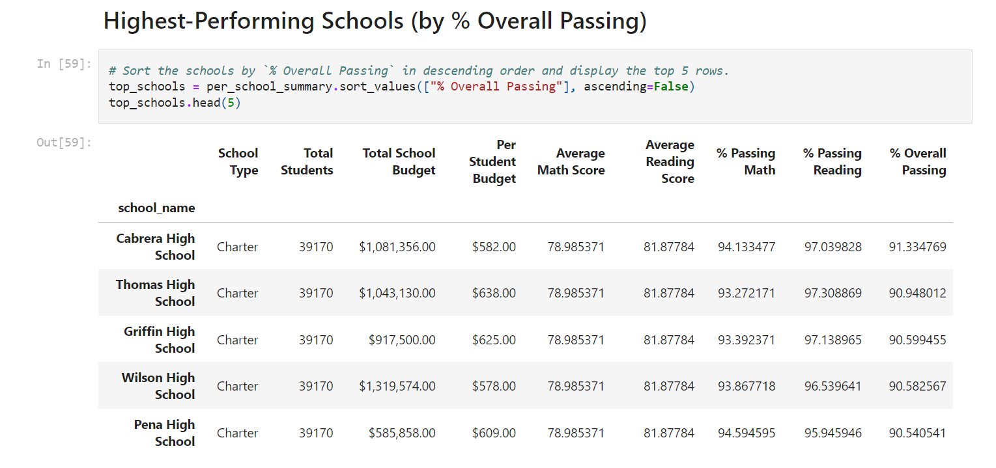

Figure 2:

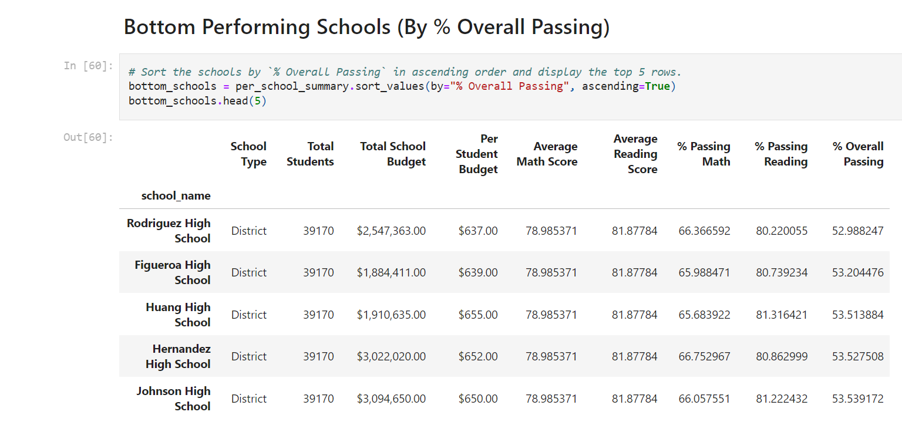

Figure 3: 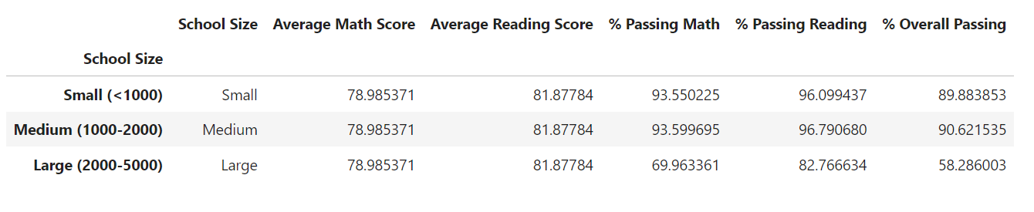

Figure 4:

